Political Cartoon Name:_____________

Objective: Students will identify the relevant political issue that is addressed in the political cartoon. They will demonstrate their understanding of the federal issue through decoding, as well as creating a political cartoon.

Method:

- Decode the following political cartoon.

Step One: write down all that you see within the cartoon.
Step Two: Answer the following questions:
- Are there any real people or places in the cartoon? If not, what images are portrayed in the cartoon?
- Are there any symbols that are known to represent something?
- Identify the specific artistic techniques used in the cartoon (i.e., symbolism, analogy, exaggeration, labeling, and irony). What is the artist trying to show the reader by using these techniques?
- What is the cartoonist's point of view about the topic portrayed in the cartoon?
- What is the issue that the artist is addressing? Give examples to support your interpretation. (Copyright 2017)

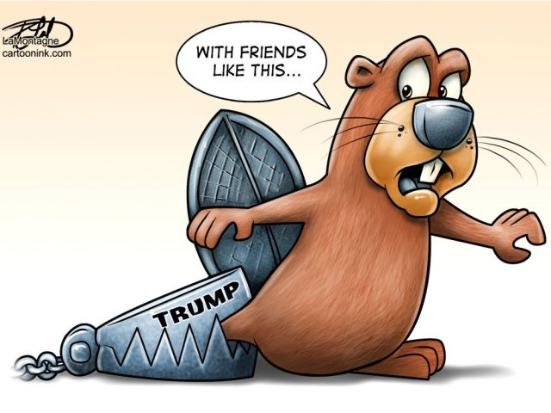

Rubric

Student listed what was in the picture_______________
Student listed the specific artistic techniques used in the cartoon______________
Student identified who the cartoon was about__________________
Student identified the political issue that was portrayed__________________
Student identified the point of view that was portrayed by the cartoonist_______

 | Excellent | Good | Basic | Not Meeting
Explores events and issues from different points of views | Student uses knowledge and skills to engage in the complex learning task | Student uses knowledge and skills at a varied level to engage in the learning task | Student uses knowledge and skills at a common level to engage in this learning task | Student struggles to use knowledge and skills to engage in this learning task
Manages and evaluates ideas and information | Student demonstrates a subtle and thorough understanding of the political message | Student demonstrates an in-depth and well-developed understanding of the political message | Student demonstrates an adequate and simplistic understanding  of the political message | Student demonstrates a limited and insufficient understanding of the political message

- Create your own political cartoon.

Choose a Canadian Federal political issue from the year 2017/2018, one that is not related to the cartoon above. This must be a Canadian federal issue. Please draw this by hand, stick figures are okay to use. Follow the directions below.

Creation:
• Use wit and humour through exaggeration of people, events, but not just for comic effect. (there must be a purpose behind the humour, you are making a point)
• They need to have a foundation in truth and be based on facts.
• People are designed as caricatures where human features are exaggerated. People can also be depicted as animals—there MUST be an identifying feature or note that indicates who you are trying to represent. (• caricature: a distorted, oversimplified, or exaggerated stereotype used to represent something else.)
• Include symbols to help illustrate your themes. For example, the beaver for Canada. (•signs and symbolism: a sign such as a facial expression, gesture, or body position, and symbols, an object used to represent something else)
• Colour, shading and the size of objects can be used to emphasize a particular point. (•shading [light and dark]: use of white space and dark shading to create an effect. •relative size: figures are drawn much larger or smaller than others to make a point or statement.)
• Include speech balloons, labels or captions to help communicate your ideas. (• labelling: words in the drawing to identify people, ideas, or objects. 6captioning: a sentence or phrase that is the title for the cartoon)
• composition: the arrangement or location of figures or objects in the cartoon

Rubric

Student chose a Canadian federal issue from 2017/2018 _______________
Student drew cartoon by hand______________
Student DID NOT PLAGERIZE_________________
Student used humor________________
Student based cartoon in truth________________
Symbols were included_________________
Colour, shading and size used to emphasize a particular point________________
Labels used___________

 | Excellent | Good | Basic | Not Meeting
Communicates ideas in an informed and persuasive manner | Student demonstrates a subtle and thorough understanding of the federal political issue | Student demonstrates an in-depth and well-developed understanding of the federal political issue | Student demonstrates adequate and simplistic understanding of the federal political issue | Student demonstrates limited and insufficient understanding of the federal political issue
Represents ideas and creates understanding through a variety of media | Uses knowledge and skills to engage in the complex learning task | Student uses knowledge and skills at a varied level to engage in the learning task | Student uses knowledge and skills at a common level to engage in the learning task | Student struggles to use knowledge and skills to engage in the learning task

