Laws of Exponents

1. Product (Multiplication) Law: to multiply powers that have the same base, write down the same base and place the sum of the exponents of the powers in the original expression as its exponent.

2. Quotient (Division) Law: to divide powers that have the same base, write down the same base and place the difference of the exponents of the powers in the original expression as its exponent.

3. Power of a Power Law: When you have a power raised to another exponent, multiply the two exponents and keep the base the same.
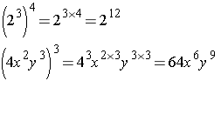
4. Power of a Product Law: When you have a product raised to a power, apply the power to both bases

5. Power of a Quotient: When you have a quotient raised to a power, apply the power to both the numerator and denominator.
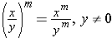
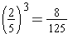

6. Zero Exponent Law: A co-efficient or variable with an exponent of zero is equal to 1. In other words, any value with an exponent of zero is 1.

7. Negative Exponent Law (Integral Exponent Law): A base with a negative exponent written in simplified form will be its reciprocal raised to the positive exponent.
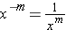
Please note that a power is simplified when it does not contain a negative exponent or an exponent on the co-efficient.

8. Fractional Exponent Law (Rational Exponents): A base raised to a fractional exponent means that you will need to convert it to radical form.
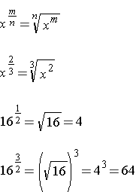

SUMMARY
