3D House Project

Your budget is: $100 000/person 3D model will be a scale of 1/24

Your home must include at least the following:
- kitchen
- living space
- bathroom
- bedroom

Outline of project
- First sketch a rough design that you would like to build
- Things to consider:
- The average size of a house in Canada is 2000 square feet
- The average ceiling height is 8 feet
- Create a scale blueprint of your house. You can create the blueprint to a scale of 1/48
- Create a budget to estimate the cost of your build. Prices are on the attached sheet.
- There are certain building codes that you will need to follow. (See attached Sheet)

Building Codes:

- Studs in walls need to be at maximum 16 inches apart
- Doors and windows need to be framed properly.

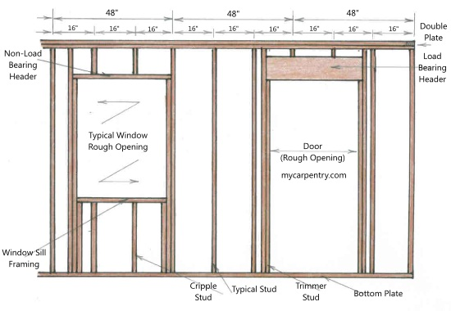
- If you building is two stories, joists need to be constructed in between the 1st and 2nd floor. Joist spacing will be a maximum of 16 inches. (Girders and subflooring are not required to meet our code) 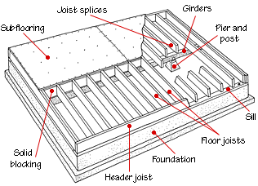
- For roof construction each rafter must be placed above a stud in the wall. (Maximum spacing will be 16 inches, just like the studs)

One Rafter constructed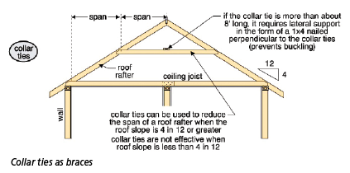
- Gable Walls must be constructed on a pitched roof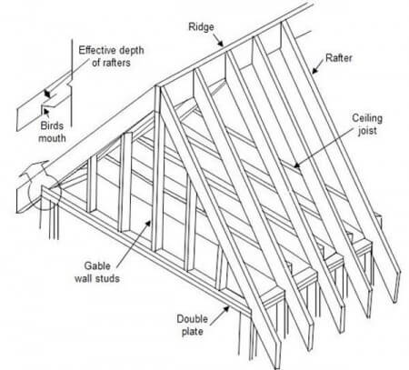
- 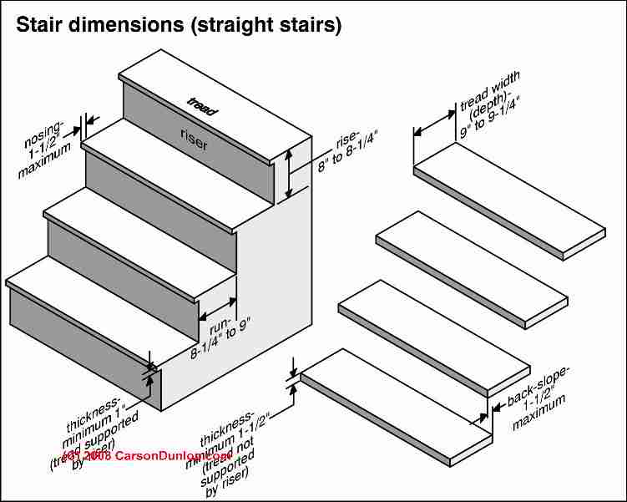

Pricing Structure
Framing
Exterior Walls are $100/ft length
Interior Walls are $50/ft length
Lumber:
¼” x 4” = $40 each
¼” x 8” = $80 each

Kitchen Appliances
Premium Appliance (LG/Samsung/KitchenAid) - $5600
Fridge - $2700
Microwave - $400
Stove - $1500
Dishwasher - $1000

Mid-Range Appliances (Frigidaire/Maytag) -$4100
Fridge - $2200
Microwave - $360
Stove - $1000
Dishwasher - $540

Economical Appliances (GE White Appliances) - $1730
Fridge - $600
Microwave – $180
Stove - $550
Dishwasher - $400

Bathroom Fixtures
Toilet - $150
Bathtub - $220
Sink - $190

Extras require you to research and attach receipt

