Exponent Checklist
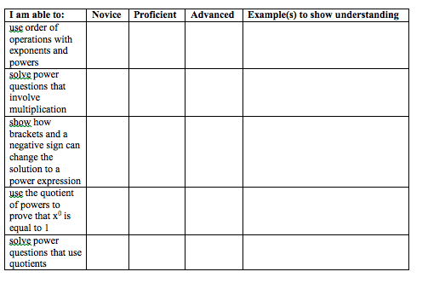

Exponent Checklist

