Elements of a Novel
- Character
–the people in a story, book, play or a movie
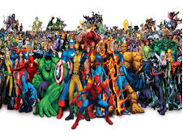
--the characters’ personalities, motives and conflicts move the action along by creating interesting situations
--appearance, history, mannerisms

Cultivating character—how a character develops his/her personality (Aristotle had it right: The only way human beings can develop true character is through constant practice, until the ethical virtue itself becomes habit.)  “You take people, you put them on a journey, you give them peril, you find out who they really are.” ― Joss Whedon  Who is on this journey within the story? | 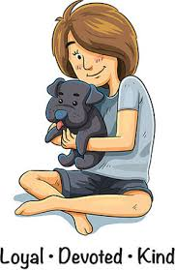

1. a. Protagonist--the leading character or one of the major characters in a drama, movie, novel, or other fictional text
--the main figure or one of the most prominent figures in a real situation
--an advocate or champion of a particular cause or idea
Synonyms
chief/central/principal/main/leading player, principal, hero/heroine, leading man/lady, title role, lead

1. b. Antagonist--a person who actively opposes or is hostile to someone or something; an adversary
Synonyms
adversary, opponent, enemy, foe, rival, competitor; opposition, competition

(me--physical)Where I was big, elbowy and grating, he was small, gracefuland smooth. …he was lauded for his velvet-black skin. His hair fell down in black curls, and my head was covered with black steel wool. And yet he loved me. (Maya Angelou, I Know Why the Caged Bird Sings, ]Bantam, 1993], p. 17)

(we--physical)My brother Ben’s face, thought Eugene, is like a piece of slightly yellow ivory; his high white head is knotted fiercely by his old man’s scowl; his mouth is like a knife, his smile the flicker of light across a blade. His face is like a blade, and a knife, and a flicker of light: it is delicate and fierce, and scowls beautifully forever, and when he fastens his hard white fingers and his scowling eyes upon a thing he wants to fix, he sniffs with sharp and private concentration through his long, pointed nose…his hair shines like that of a young boy—it is crinkled and crisp as lettuce. (Thomas Wolfe, Look Homeward, Angel [Simon & Schuster, 1995, originally published 1929], p. 135)

(me--personality) ‘[Mrs. Ramsay] looked at him. He was such a miserable specimen, the children said, all humps and hollows. He couldn’t play cricket; he poked; he shuffled. He was a sarcastic brute, Andrew said. They knew what he liked best – to be for ever walking up and down, up and down, with Mr. Ramsay, saying who had won this, who had won that …’ (Virginia Woolf, To The Lighthouse, p. 11)

(we—personality) ‘He was a rich man: banker, merchant, manufacturer, and what not. A big, loud man, with a stare, and a metallic laugh. A man made out of coarse material, which seemed to have been stretched to make so much of him… A man who was always proclaiming, through that brassy speaking-trumpet of a voice of his, his old ignorance and his old poverty. A man who was the Bully of humility.’ (Charles Dickens, Hard Times, p. 18)

(you—physical and personality)
Guy Montag  (physical) | Text with page #
Guy Montag
(personality before)
Guy Montag
(personality after)

