Choose your own adventure Name:
DO NOT CHOOSE THE SAME ADVENTURE AS THE PERSON BESIDE YOU
Create a linear equation in the format y=mx+b, where m is equal to 2 and -5<b<5.

Create a linear equation in the format y=mx+b . Where 0<m<1 and -10<b<10.

Create a linear equation in standard form. Meaning the equation would look like x+y=w. Remember that w represents any number.

Graph your three linear equations:

Cell Phone Plans
These screen shots are from koodo’s mobile website. Choose a plan and/or add on. Use the information to graph the total cost of a phone over time.

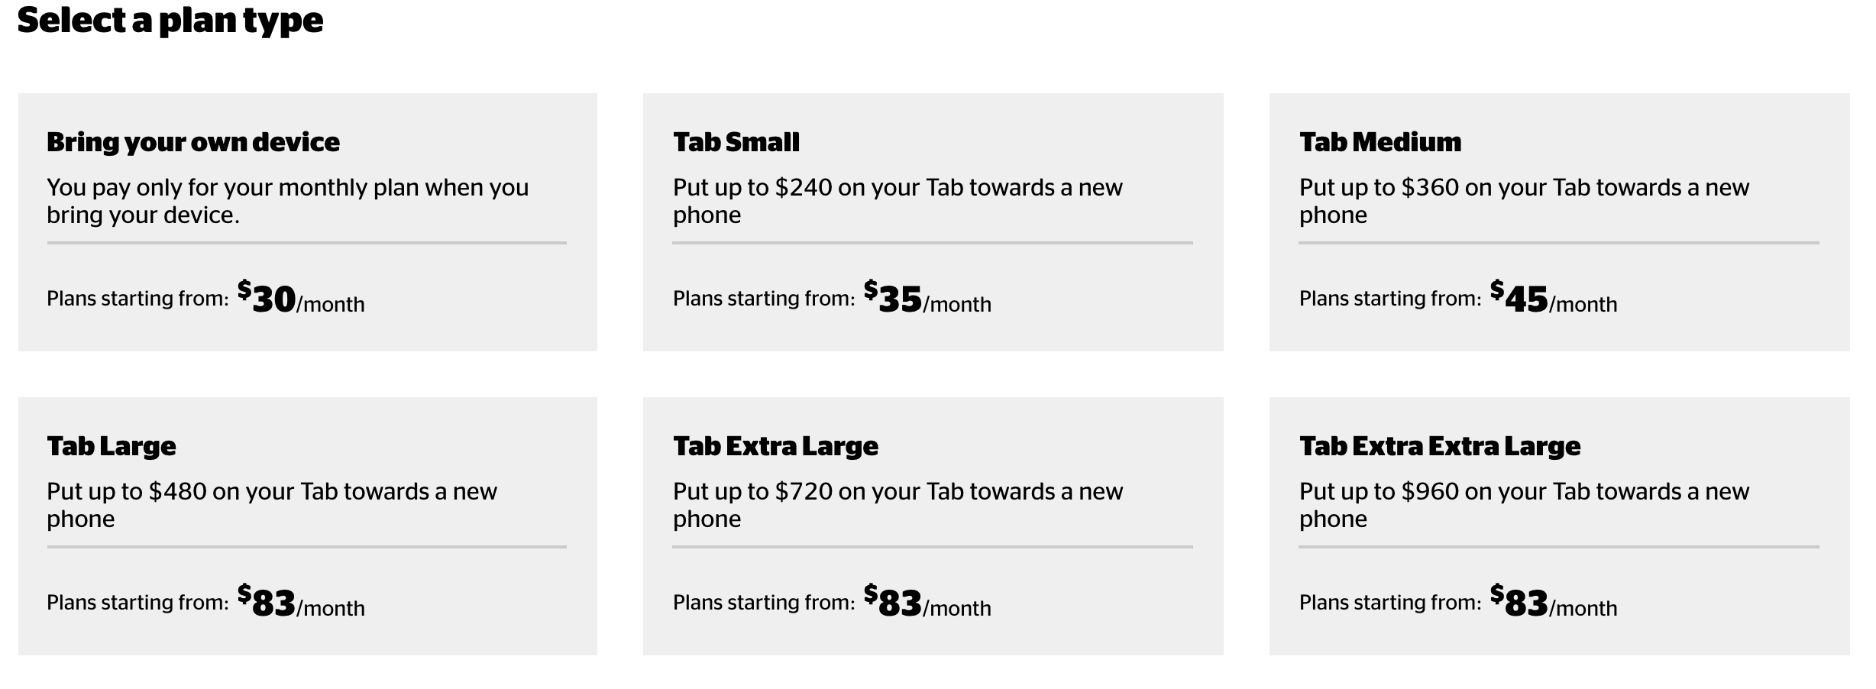
Select an add-on
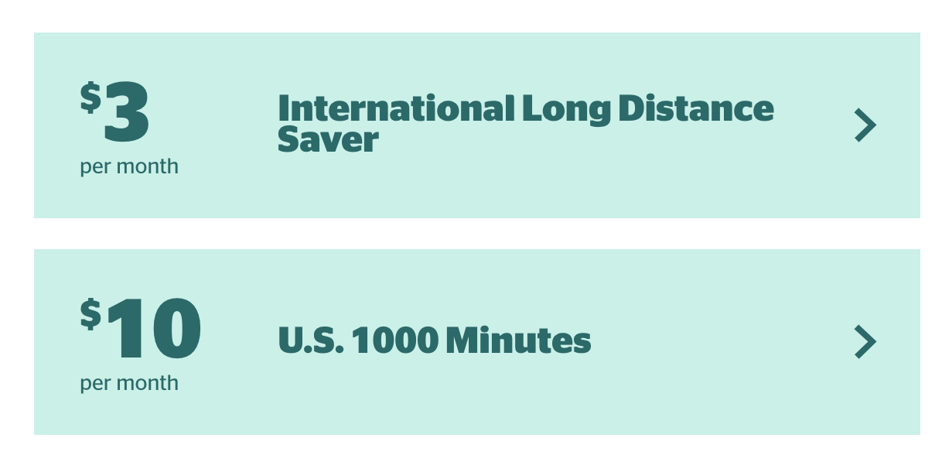

Can you represent the total cost with an equation?

Can you calculate how much money you would spend if you had the same phone and same plan for 20 years?

Marking Scheme:
___ Models and Communication ___ Procedures ___ Estimation (more to come on this later)

